How do you measure learning efficiency?
The problem with efficiency
Most people think about learning efficiency as how much content you can cover in a learning session. For example, an efficient learner can cover 5 lectures in 2 hours.
However, this is very problematic for multiple reasons:
- It does not consider the retention of knowledge
- Extra time is spent relearning information that is forgotten
- It does not consider the quality of learning that occurred or the person's ability to perform and use their knowledge in different ways
Ultimately, thinking about efficiency as the "amount covered per session" is a useless metric.
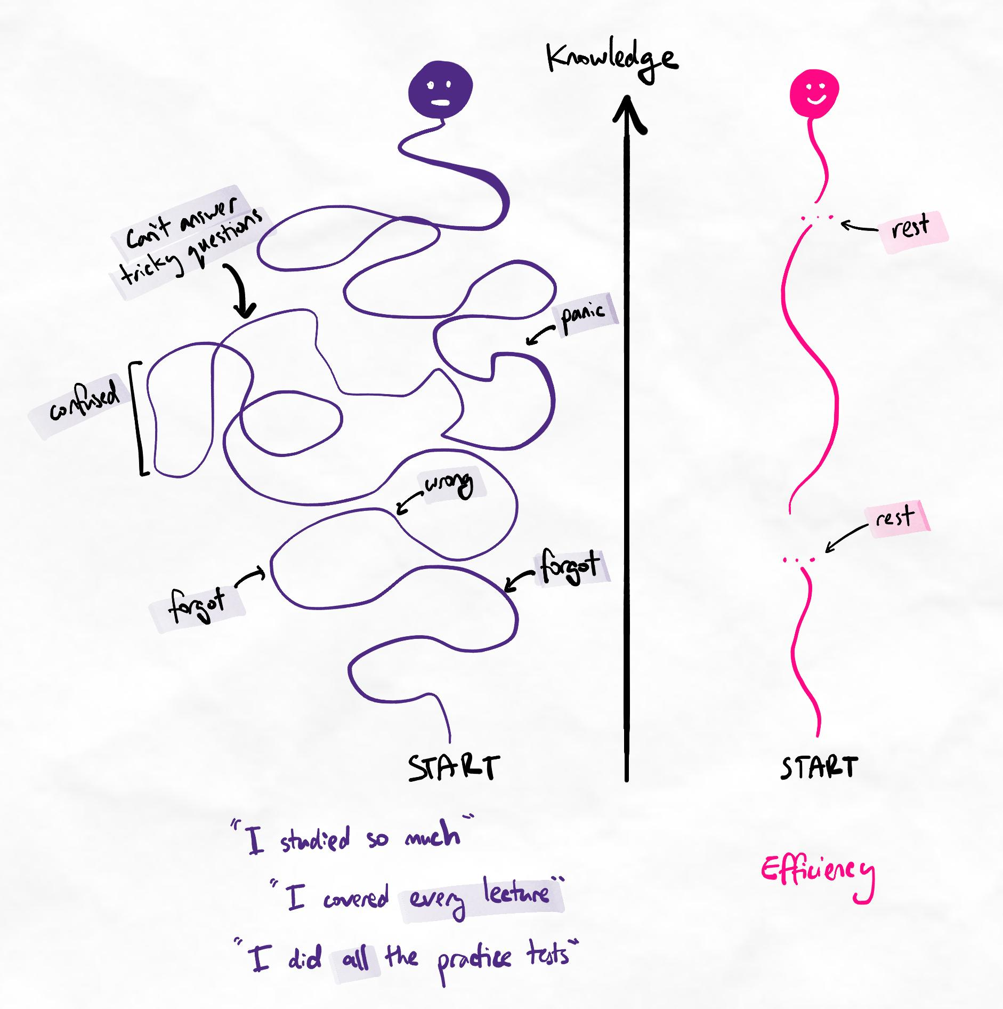Efficient learners focus on learning to high quality. Inefficient learners focus on "doing more".
The components of efficient learning
What we want to know is the amount of time it takes for a learner to gain high-quality, usable knowledge and retain this information for their purposes. Efficient learning can be summarised as:
- Achieving the necessary mastery of knowledge
- Having sufficient retention of this knowledge at each level of required mastery
- Being able to achieve the above in a short amount of time
The learning efficiency equation
Learning efficiency = Total mastery and retention over Total time spent learning
For example, we may say that an inefficient learner achieves 50% over 100 hours, while an efficient learner achieves 90% over 50 hours. We will explain what this means below.
Total mastery = average of all partial masteries
Partial mastery = retention per mastery level / required retention per mastery level
How to calculate the values
- Identify the highest and lowest required knowledge mastery levels. Refer to our article on "How to measure knowledge mastery".
- Assess your retention after one week (as a percentage) for each level. We use one week because our spacing intervals should allow for a one-week retrieval session. It can be extrapolated to the level of retention you may have for an assessment.
- Identify the retention you require for each level for your assessment.
- Calculate partial mastery by dividing your real retention after one week by the required retention.
- Calculate total mastery by taking the average of your partial masteries.
- Calculate the total time you spent on all learning and retrieval sessions for this subject (across however many weeks).
Example

Jeremy is studying for a second-year university economics exam.
- Knowledge mastery (highest): For his level, he is assessed at a maximum of level 4.
- Knowledge mastery (lowest): He is sometimes asked about specific fact recall, so he is assessed at a minimum of level 1.
After a couple of weeks of studying, Jeremy has found that his one-week retention is as follows:
Level | Retention | Required for assessment
1 | 60% | 80%
2 | 60% | 90%
3 | 50% | 70%
4 | 30% | 60%
By dividing retention by the percentage required for assessment, we can calculate the partial masteries:
Level | Retention | Required for assessment | Partial masteries
1 | 60% | 80% | 60%/80% = 75%
2 | 60% | 90% | 60%/90% = 67%
3 | 50% | 70% | 50%/70% = 71%
4 | 30% | 60% | 30%/60% = 50%
Simple summary
In words, this tells us that Jeremy has only reached 50% of the mastery and retention he needs for his assessment. On the other hand, he has reached 75% of his requirements for level 1 knowledge, such as fact recall.
To calculate his Total mastery, we simply average the value of all the partial masteries.
The average of 75%, 67%, 71%, and 50% is 66%. Therefore, Jeremy's Total mastery is 66%.
He has spent a total of 30 hours studying so far.
Therefore, we can say that Jeremy's learning efficiency is 66% over 30 hours.
Inefficient learners
When we complete this calculation for inefficient learners, we often find that as hours increase, the total mastery percentage does not increase much. For example, if Jeremy is not a very efficient learner, his 30 hours may increase to 60 while his mastery only improves to 76%.
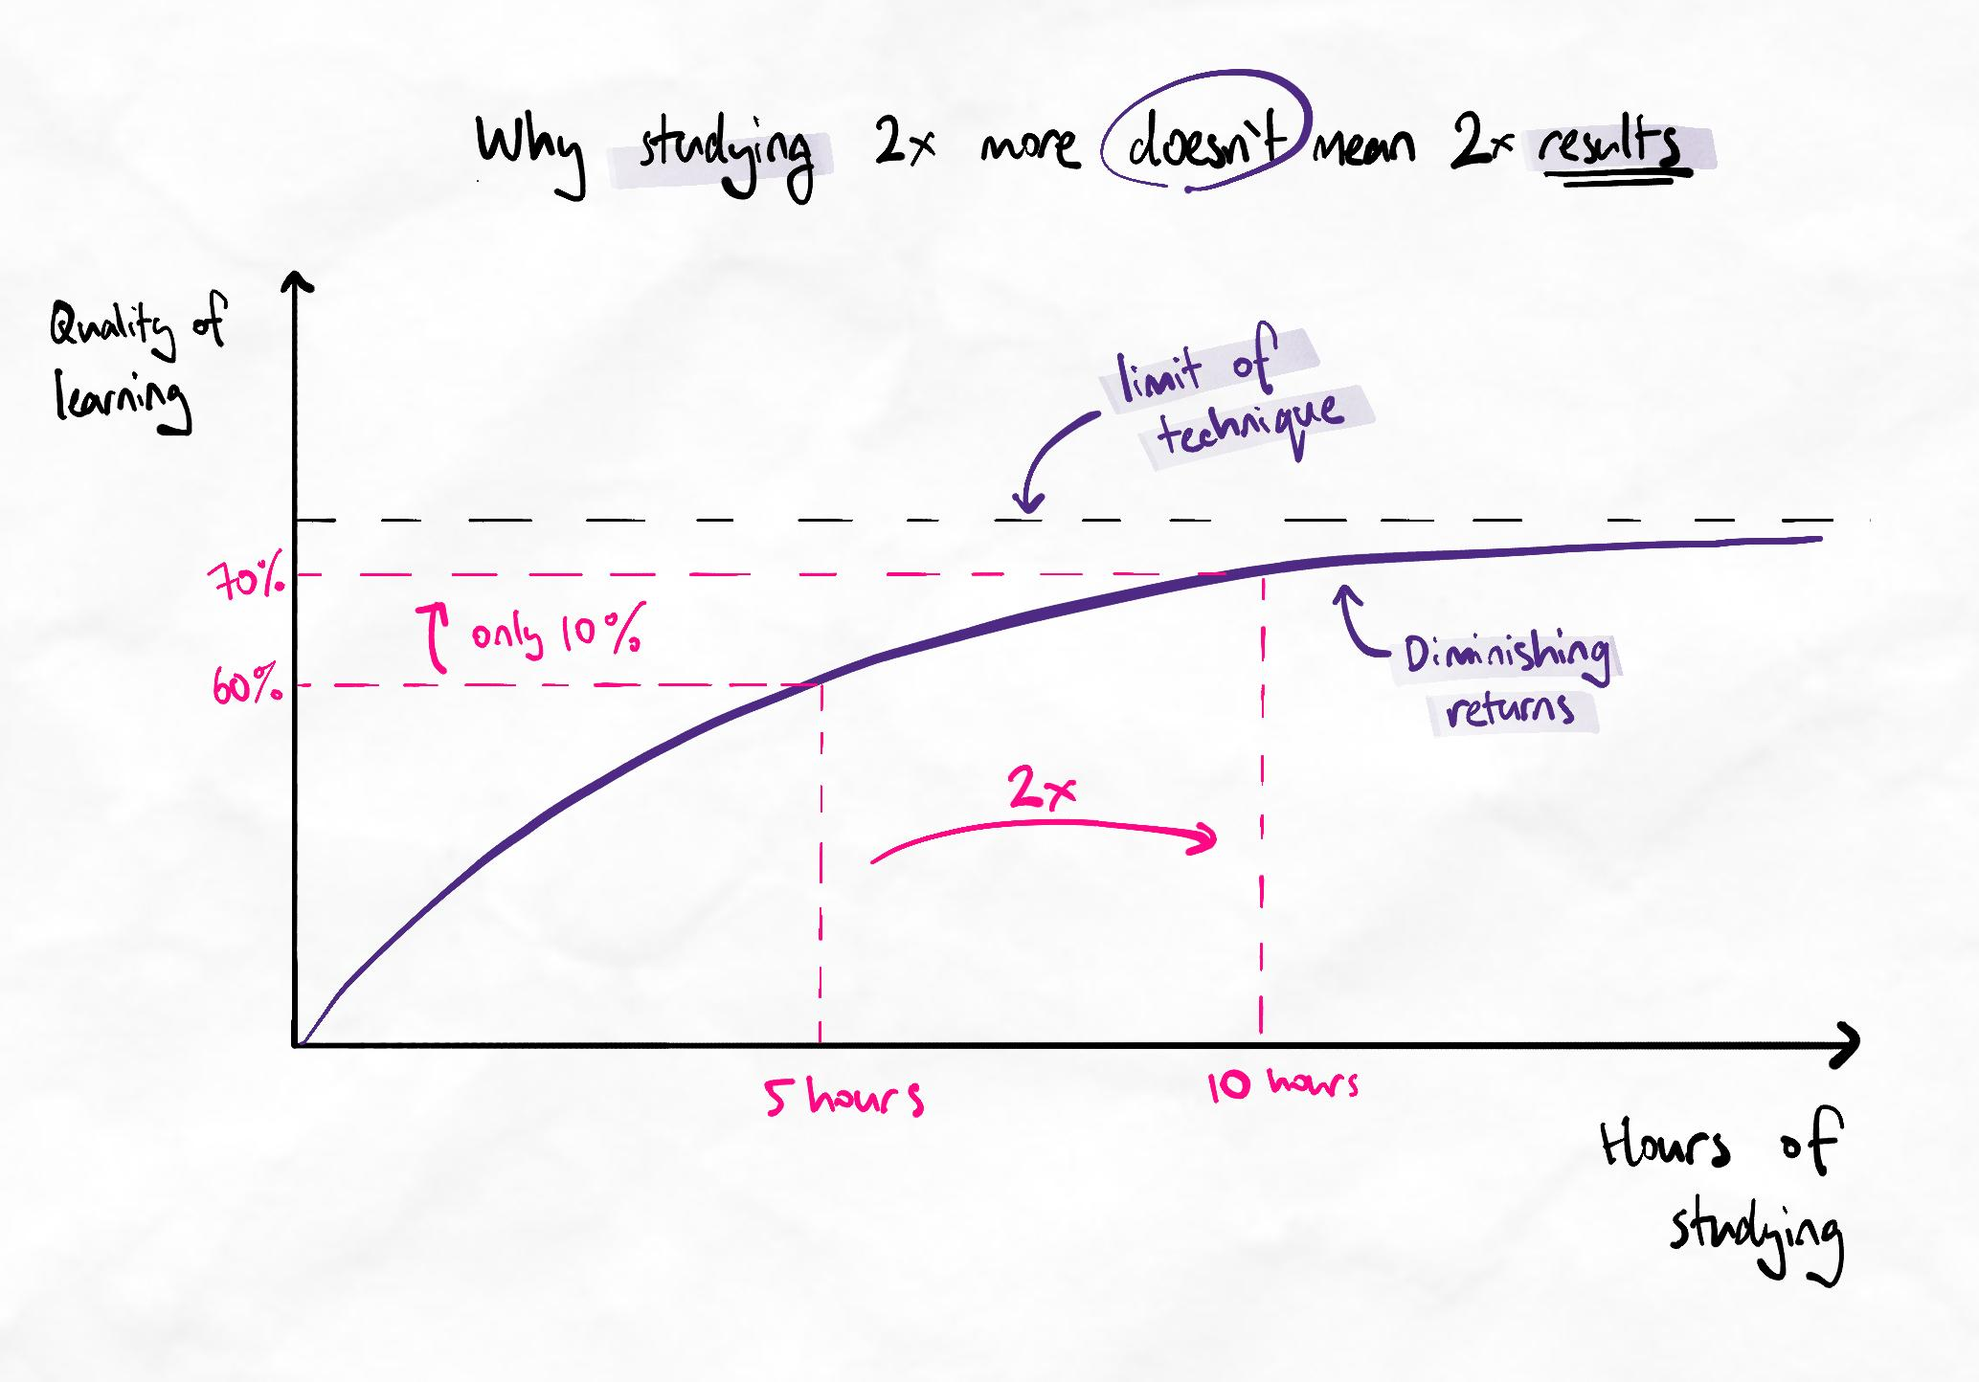If the methods are limited, more hours of studying produces smaller and smaller benefits.
By doubling his hours of studying, his results have only improved by 10%.
This is because certain methods are inherently limited.
Analogy
It's like trying to build a house with only a hammer. At first, you can build more and faster by spending more time building and swinging your hammer. However, at some point, there are certain tasks that you cannot achieve with only a hammer. It doesn't matter how much time is spent or how hard we swing it.
This is why efficient learners must use methods specifically to achieve certain mastery levels.
Key considerations
- Efficient learners can achieve a higher percentage in less time.
- More time does not necessary increase the percentage of achieved mastery and retention. In most cases, the rate of forgetting becomes so high with large volumes of learning that learners never reach 100% retention, especially at higher levels of mastery.
- The method of learning strongly dictates how easily higher levels of mastery can be attained. Some methods are frankly incompatible with achieving higher mastery, unless you have very high deep processing.
- Learning efficiency depends on the required level of mastery and retention. Lower requirements are easier to meet in less time.

Example values of efficiency for different learner scenarios

Learner type | Mastery profile | Time investment | Example values
Inefficient methods, low deep processing | Achieves lower levels. Struggles with higher levels. Retention generally low. | High due to excessive relearning. | 50% over 100 hours. Total mastery does not improve by much when hours increase.
Inefficient methods, high deep processing. | Achieves most levels of mastery. Retention low to moderate, depending on deep processing. | Moderate. | 70% over 50 hours. Total mastery may increase slowly with increase in hours.
Efficient methods, low deep processing | Achieves most levels but struggles with higher levels. Retention generally moderate. | Moderate to high. | 70% over 50 hours. Total mastery increases proportionally when hours increase.
Efficient methods, high deep processing | High achievement across all levels. Retention high. | Low | 90% over 30 hours. Total mastery increases proportionally when hours increase.

